**How do abundances of photosynthetic proteins change with leaf age**?

Hypotheses:

* Abundance of light harvesting proteins increases with age to counter reduced light interception
  + Is there any effect of leaf age independent of increased shading? Can’t answer this directly but worth discussing
* Calvin cycle & electron transport proteins remain constant or are proportionally reduced as leaves age
* Nitrogen is progressively allocated to recalcitrant structural and defensive protein throughout leaf lifespan, so older leaves contain proportionally less photosynthetic protein
  + Re: Onoda et al. 2003 “Allocation of nitrogen to cell walls decreases photosynthetic nitrogen-use efficiency”
  + But see Hikosaka & Shigeno 2009 “nitrogen allocation to cell walls does not explain the variation in PNUE”
  + Have not quantified structural / cell-wall associated proteins here

Influence of leaf age on photosynthetic protein amounts: raw data vs standardised to newest leaf (for a given biological replicate of a given species)

1. Total protein

Df Sum Sq Mean Sq F value Pr(>F)

leaf_age 1 1.295e+09 1.295e+09 11.61 0.000788 ***

Residuals 207 2.310e+10 1.116e+08

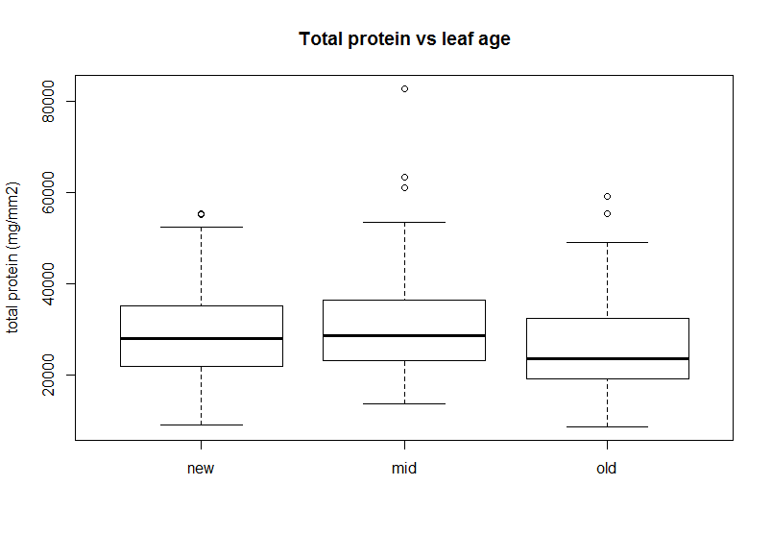

Df Sum Sq Mean Sq F value Pr(>F)

leaf_age 1 1.50 1.500 7.81 0.00571 **

Residuals 195 37.45 0.192

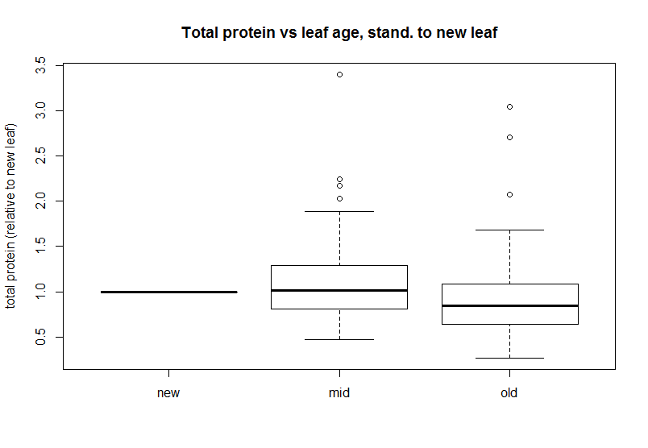

1. Photosytems

Hypothesis: abundance of light harvesting proteins increases with age to counter reduced light interception

Df Sum Sq Mean Sq F value Pr(>F)

leaf_age 1 0.006 0.006049 3.393 0.0669 .

Residuals 207 0.369 0.001783

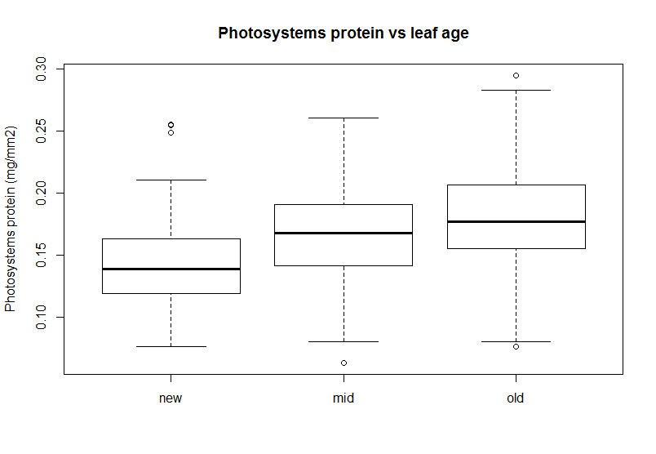

Df Sum Sq Mean Sq F value Pr(>F)

leaf_age 1 0.228 0.2276 3.242 0.0733 .

Residuals 195 13.689 0.0702

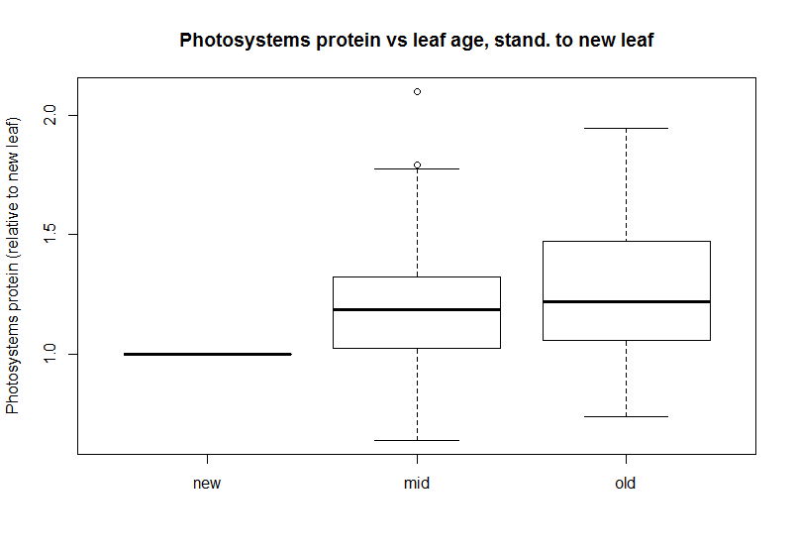

1. Electron transport chain

Hypothesis: Calvin cycle & electron transport proteins remain constant or are proportionally reduced as leaves age

Df Sum Sq Mean Sq F value Pr(>F)

leaf_age 1 0.000015 1.499e-05 2.46 0.118

Residuals 207 0.001262 6.095e-06

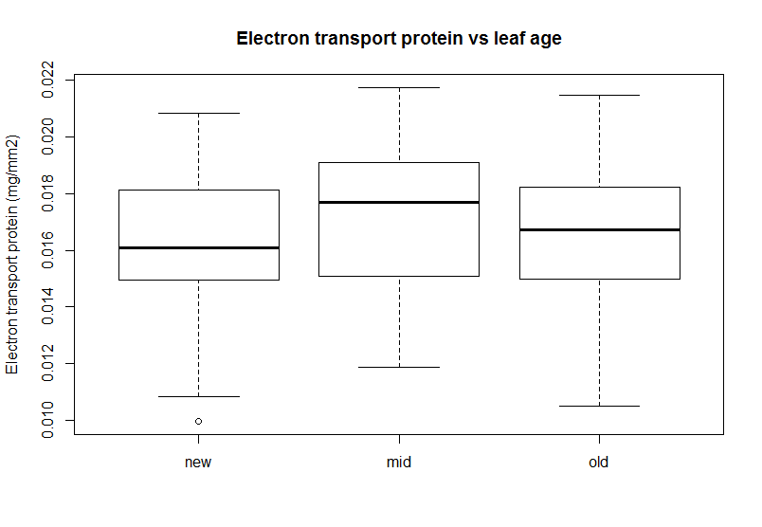

Df Sum Sq Mean Sq F value Pr(>F)

leaf_age 1 0.000015 1.499e-05 2.46 0.118

Residuals 207 0.001262 6.095e-06

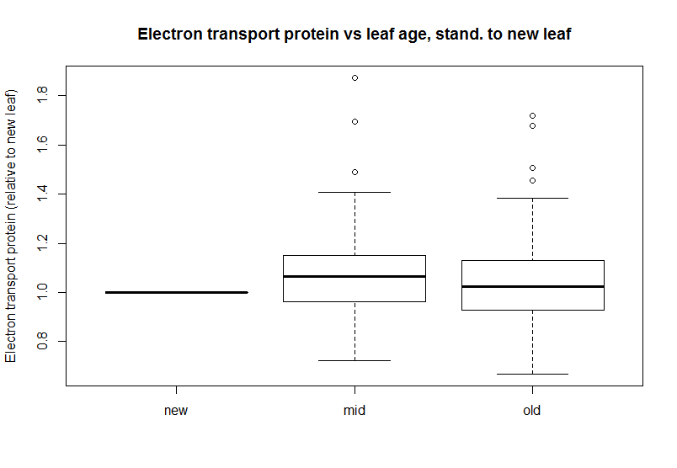

1. Calvin cycle

Hypothesis: Calvin cycle & electron transport proteins remain constant or are proportionally reduced as leaves age

Df Sum Sq Mean Sq F value Pr(>F)

leaf_age 1 0.0282 0.028207 12.15 0.000599 ***

Residuals 207 0.4806 0.002322

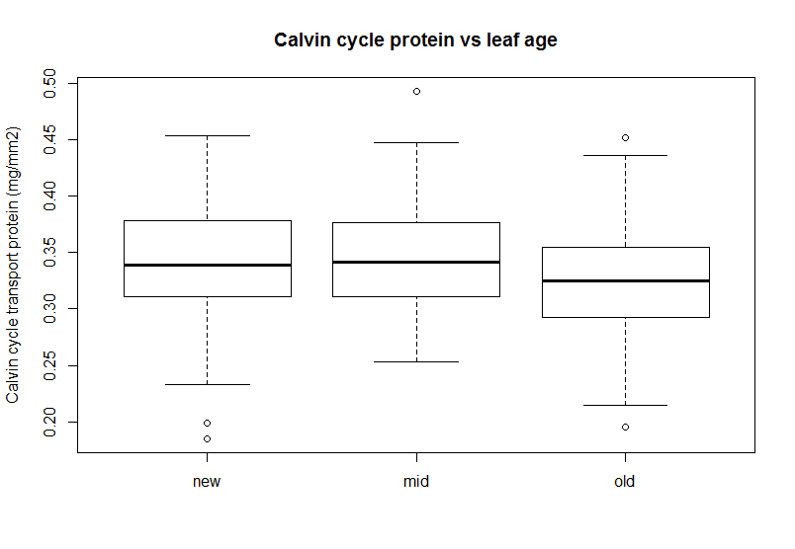

Df Sum Sq Mean Sq F value Pr(>F)

leaf_age 1 0.212 0.21150 4.646 0.0324 *

Residuals 195 8.877 0.04552

